Navigation Bar

Logo
Gatherings
Experiences
Our Journal
Why we’re here
Plan With Us

HEADER

Personal Travel Curators · Est. 2024

BIG Copy
Travel that feels like
a long exhale.
One-line clarity statement below headline:
Curated slow travel experiences, intimate gatherings, and restorative journeys for people who need a softer way to experience life.

CTAs - Explore Gatherings | Plan a personal journey

Revolving strip
Sri Lanka - Relearn the art of Slow Travel - Aug 20 - 26th, 2026 | Block your slot now

Section 3 - Decision Detox
We Dont sell Trips
We Curate Breaks
Decision fatigue is one of the quietest exhaustions of modern life. Founders, creatives, managers, people constantly carrying responsibilities & we’ve seen how tiring it becomes to always be “on.” Always deciding.
So we wondered: What happens when someone else takes the driver’s seat for your break?
Someone who understands pacing, intention, and the kind of experiences that don’t just look good, they feel good too.
So we created journeys where the mental load softens, the pace slows, and all you really have to do… is arrive.
— Tanya & Keerthi, Founders

RIGHT SIDE IMAGES & DESIGN LAYOUT

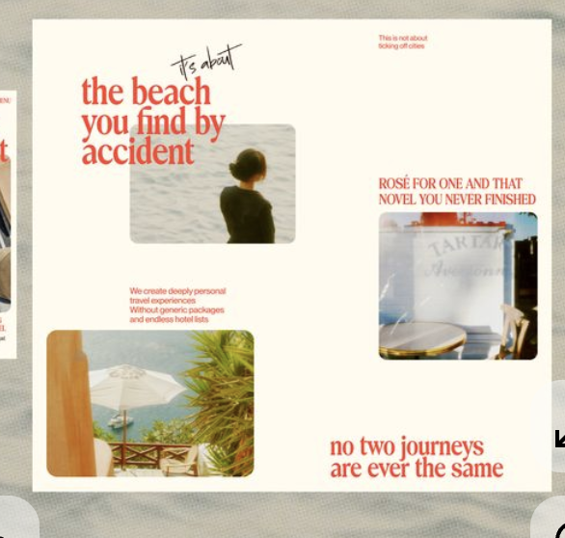
Something like tihs

Image:
Wet hair after swimming
Caption:
The afternoon nobody checked their phone
Image:
Half-finished wine glasses
Caption:
Dinner that turned into a four-hour conversation
Image:
Train window
Caption:
The first moment your brain finally went quiet & happy

Image - Someone asleep in a car ride
“The nap nobody apologised for”

Images can be small - the text can be scattered, all dont have to be polaroids
They can be text over image and so on - like handwritten notes

<we can see if we have our own images for these>

Who we vibe with
emotionally exhausted
people in transition
over-thinkers
recovering high achievers
creatives
quiet romantics
burnout ceo’s & executives

Sub line - What are you craving more of lately?

Section 5 GATHERINGS / UPCOMING TRIPS

Upcoming Gatherings 2026

For people craving slower mornings,
good company, and a few days away
from constantly holding everything together.

[Large Sri Lanka Image]

AHANGAMA, SRI LANKA

The Slow Transit

6 days of slow travel, shared meals,
ocean air, thoughtful conversations,
and the kind of rest that doesn’t end
when the trip does.

For:
creatives / founders / over-thinkers /
people in transition / anyone needing softness

10–14 travellers · hosted experience
[Reserve Your Seat →] <link to google form>
Image on the left & information on the right
IMPORTANT UX NOTE
Since there’s only ONE gathering:
make the image MUCH larger.
Treat it almost like:
- an editorial feature
- a magazine cover story
- a cinematic invitation
not a product card.

Can do something like this maybe

6. Service section
We can plan the whole trip, or just the parts you want to remember forever
<change font & styling>
what we take off your plate - CTA line
service cards:
- Complete personal itinerary design
- Local experiences
- Restaurant & local activities recommendations
- Stays
- Honeymoons
- Corporate Events
- Family Trips
- Friends Trip - Guided / Non - guided

Remove decision detox from there- we have it on top already

7. Reviews - Experiences
<keep the same name so there is corelation>
Design here need to change - more text, less images
- Mona champ
- Grace & joel
- Siddharth & family
- Konidela family
- Corporate planning

8. JOURNAL SECTION

FROM THE JOURNAL
<no subtext needed>
Categories
- Slow Travel
- Emotional Geography
- Travel & Burnout
- Founder's Notes
- Rituals & Rest
- Gathering Diaries
4 blogs each month to be updated - follow up
Remove corporate offsite section - we have it in services anyways - should be enough
Can do a blog on it and link CTA

Newsletter sign up section
“Slow letters, once a fortnight.”
Thoughts from the road, notes on rest, places we can’t stop thinking about & some more love.

email input
[subscribe]

Footer navigation

Design changes
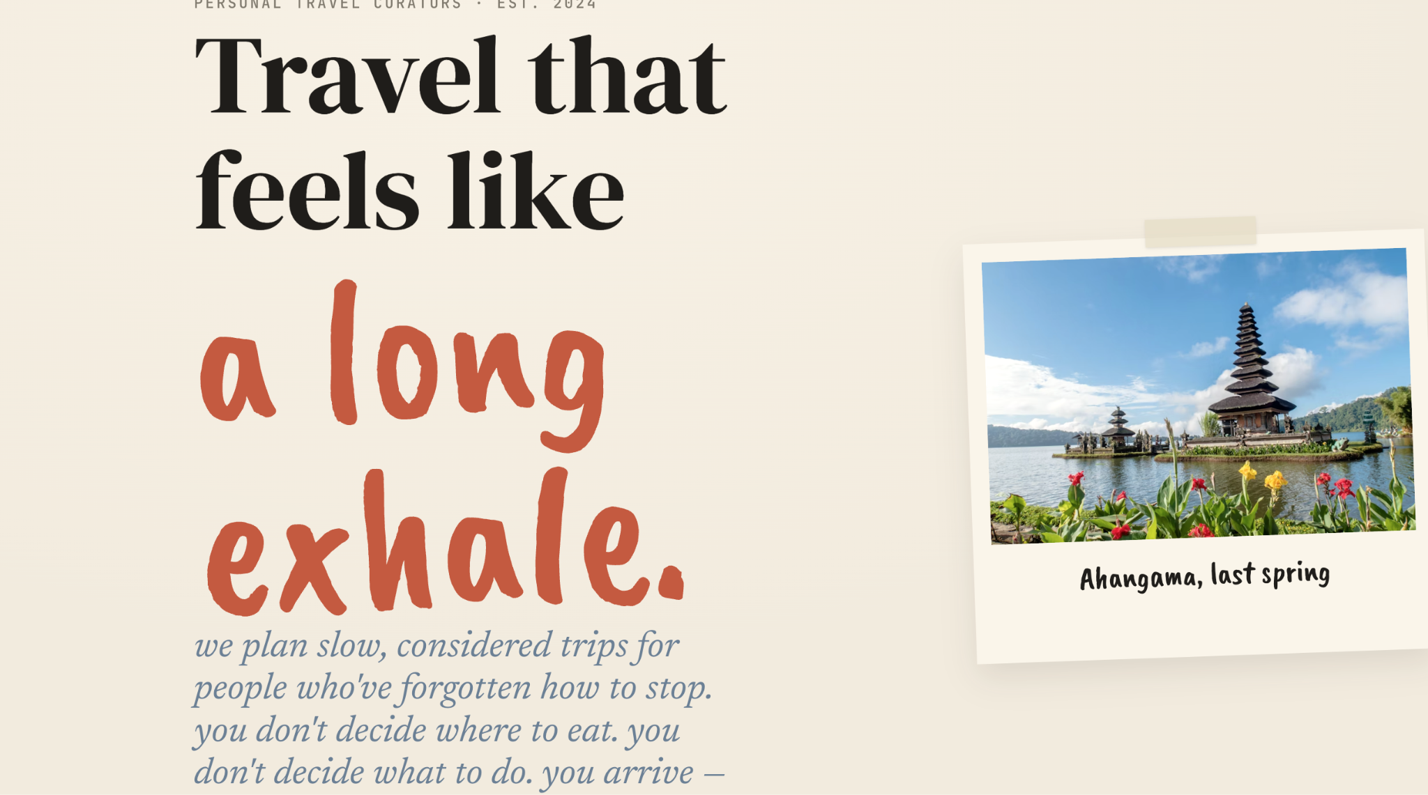
Reduce the header font size
Spacing between header & subheader

Remove the bali image and we need a simple collage of images to show diff places and slow travel so the curation part is visible

